Project Report
So far, I’ve built most of the Moon environment and it is looking pretty realistic. The terrain now has proper Debris, rocks, uneven surfaces, and lighting that changes with a big textured sun that can animate across the sky. I also added a starfield, falling asteroids, and about seventy textured rocks scattered around for detail. The first-person camera and smooth mouse movement are working well but need improvement, and I made a third-person debug view to help test things. Altogether, it’s starting to feel like an actual Moon scene but still, it needs more development.
Next, I’m planning to work on adding the more objects to moon and its environment and the crashed plane structures that were in my proposal, which are previously made by me in assignments, I will develop them more to look very realistic. I’ll start experimenting with collision feature and simple alien movement patterns before Thanksgiving. I’ve had a few challenges with lighting performance when too many textured objects are on screen, so I might optimize that part soon. Moon physics is put as last task to be mad, so not touching that side for now. Overall, the visual side is nearly there, and I’m now moving toward gameplay, interaction.
This is what I want to make and my project to look like as a base view:
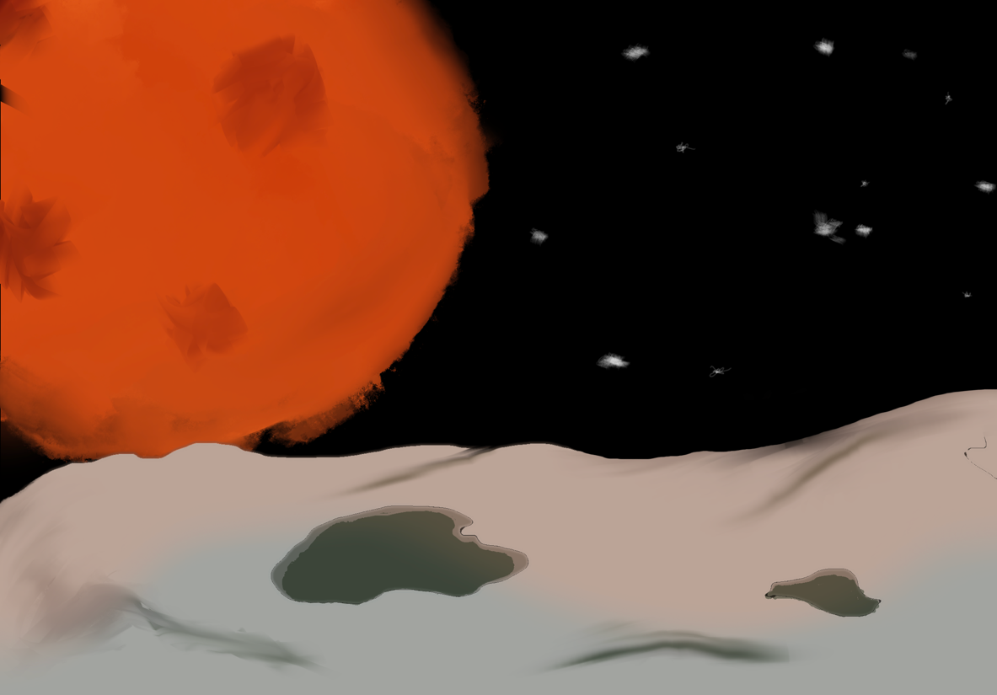
This where we are at:
